**Chapter 1**

**Introduction**

Over the years, technology has revolutionized our world that has an amazing tools and resources, putting useful information at their fingertips. “Today in an era of advanced technology, where every part of our daily lives is related to the science of craft in one way or another. There’s no doubt that over the years technology has been responsible for creating amazingly useful resources which put all the information we need at our fingertips. The development of technology has led to so many mind-blowing discoveries, better facilities, and better luxuries, but at the same has dramatically changed our daily lives” (Zlatko Stojano, February 23, 2017).

“Technology has impacted people, businesses and society as a whole. The roles that technology has played on communication, business and education have been more than impactful.   
As modern technology continues to grow and advances, so does the future effect on our life and society. The impact of technology on communication business and education, has been extensive and largely positive by helping people keep in touch” (Ramey, Karehka. "Technology And Society - Impact of Technology On Society." Use of Technology).

The Binalbagan BJMP existing system has a manual entry for the visitors. Visitor logs will be recorded in hand written registers. It usually is a tedious job to maintain the records for the users. The retrieval of the information is not as easy as the records are maintained in the hand written registers. Since collecting visitor has not been computerized, the proposal of transforming the present system was alluring and decided to face the challenge and design a solution for it.

The proponent come up with the idea to design a system for Binalbagan BJMP in terms of monitoring visitors by using ID scanned by a barcode scanner of every visitor for the easiest way of monitoring who enter the jail. It will help the management reduced the performed work. The system helps the acceleration of the in charge monitor when it comes in the visitor’s log. This system will provide automated, fast and easy recording of information and monitoring of the visitor. At the time of admission each visitor is assigned a unique barcode. This unique barcode is generated by visitor personal information and enrolment number and by using barcode scanner these barcodes is used to retrieve the visitor information from the database. This system aims in reducing the manual effort and improving the efficiency of the data retrieval.

**General Objective:**

The main objective of this study is to develop a visitor monitoring system for Binalbagan BJMP to improve and securely monitor the inmate’s visitor. The system will provide the automated and accurate process of monitoring visitor.

**Specific Objective:**

1. **To create and design following features:**
2. To provide the monitoring of visitor
3. To provide records of inmate’s information
4. To provide reports for inmates
5. To provide reports for visitor
6. To Evaluate the system in terms of:
   1. Functionality
   2. Reliability
   3. Efficiency
   4. Accuracy

**Project Scope and Limitation**

This system is intended only for Binalbagan BJMP focused in monitoring of visitor who enters the jail everyday with the use of barcodes. It includes the entire process of storing, retrieving and maintaining data of the inmates that includes their personal profile, case information, and the status of their cases.

The BJMP Visitor’s Log Monitoring System is accessible by the authorized users and personnel of the jail. By using the given password and username the system users can easily update and encode the data of the inmate’s visitors.

**Significance of the Study**

This study is significant to the following:

* **Jail personnel** -enable to view personal information and cases of the prisoners and easily identify the inmate’s visitor’s identities and information. They can monitor how many visitors visits every day.
* **Visitor-** since they don’t need to write their information everytime they visit the jail.
* **Researcher-** this study is significant to the researcher to enhance their skills in developing a system and creating research.
* **Future Researcher-** this study will provide preferences and ideas that will help the future researchers to help them develop a new system which is related to the current system.

**Definitions of Terms**

For the clarification and further explanation of words used in the proposed system, the key words that has been used will be defined as follows.

**Barcode Scanner** - A Barcode scanner is an electronic device for reading printed barcodes, it consists of a light source, a lens and light sensor translating optical impulses into electrical ones. It contains a decoder circuit analyzing the data provide by the sensor and sending it to scanner’s output.

**Inmates** - a person who is kept in a prison.

**Jail Personnel** - a person who is in charge of a prison and can also benefit the system as they cannot work difficultly.

**Monitoring –** systematic process of collecting and analyzing the information of the inmates visitors including the time, date and the name of the inmates they want to visit.

**Visitors** - persons who are the target users and the one who benefits the system.

**Chapter 2**

**REVIEW RELATED LITERATURES AND SYSTEMS**

This chapter deals with a review of publication, research and investigation of both local and foreign and foreign studies that is related to Binalbagan BJMP Management System in which can be a reference to improve and upgrade the propose system.

**Local Prior Arts**

**RFID Based Employee Attendance Monitoring System for LSPU SPCC (Manuel Luis R. Alvarez, 2015)**

According to the study of Manuel Luis R. Alvarez, Employee attendance monitoring system is important in an organization. It involves observation of behaviors, time keeping and site security. It is important to have such a system that will be used in this kind of operation. The special project is focused on employee attendance monitoring system using RFID. An additional method of attendance monitoring is for the existing biometrics at Laguna State Polytechnic University. The project was designed using RFID reader for the scanning of RFID tags, RS 232 to TTL converter to convert the data coming from the reader. A visual basic programming software was used for the program and Microsoft Access for the database. All the readers were connected by a local area network. The existing biometrics scanner was linked into the same database of RFID. Once an employee enters the campus their time in/out will be saved to a common database. Functionality was tested and the test results showed that 100 % of the RFID tags were detected and the maximum distance was 3 inches. The results shows that the system is reliable in terms of its functionality and the sensor reading is accurate. For further studies I would suggest that, aside from the Radio Frequency Identification tags future researchers can use ZigBee technology as its transmitter and receiver in replacement of the Radio Frequency Identification System

This system is related is related to the proposed system since it also aims to monitor the attendance of an organization with the use of RFID.

**CEAT Passport Attendance Monitoring System Using Fingerprint (Corpuz, Eduard C., Cuales, Ricky Paolo A., 2015)**

The main objective of the study is to create a CEAT passport attendance monitoring system using fingerprint. Using biometric data particularly the fingerprints of the students, the struggles in event registration regarding the CEAT passport booklets and manual registration in events are addressed. With the use of the proposed system, not only can the production cost of booklets be removed from the annual budget, the convenience in the events can also be dramatically improved. The design involves the development of the system, integrating the fingerprint scanner in the software for the administrator or the college student council, and creating an interface for the students to replace the CEAT Passport booklets. The study proposed an installable and applicable system that improves the overall performance of the former CEAT Student Passport booklets.

**Local Related Literature**

**Developing a Grading and Monitoring System: Towards an Effective Academic Evaluation (Genesis Lalas, Dr. Dave E. Marcial, May 2016)**

Grading, monitoring, and reporting are varied activities involved in most general academic evaluation. The researcher developed the Grading and Monitoring System to address specific needs of end-users in Metro Dumaguete College (MDC) who experienced manual and inefficient grade computation, limited chance for grade and progress consultation between faculty and students, and inefficient distribution of reports across departments. It was the main objective of the study to conduct an analysis of the current grading and monitoring system at MDC with the hope that results would aid MDC’s decision–making regarding the issue at hand. The project methodology involved Rapid Application Development (RAD) following the Software Development Life Cycle (SDLC) where one of the required components was prototyping. The development of the prototype used Microsoft Visual Studio 2013 C# for the code implementation and Microsoft SQL Server Management Studio 2014 for data connectivity using MySQL. The prototype boasts the following features first the GradeBook, with Activity Planner; second Student workspace for grade and progress monitoring activities and third reports with applied analytics and statistics, for Business Intelligence and decision support.

This study is similar to the proposed system since it also aims to replace manual process in

**Foreign Prior Arts**

**Automated Monitoring System Designing a Laboratory Equipment Tracking System (ELYASIZADEH, SAMRAND, 2016)**

This thesis focuses on improving the laboratory equipment monitoring system of Lahti University of Applied Sciences (LUAS). The conventional method of checking items for every laboratory session is based on manual monitoring, which leads to a challenge for the lab administrator to monitor the flow of the items. The objective of this thesis was to provide a design to replace this old-fashioned manual system with a system that is based on new technologies. The main task of the designed system is to automatically identify personnel, students, and laboratory equipment for every loan of equipment in a laboratory session. To present a systematic and practical design for automated monitoring, a solution has been provided, using Radio Frequency Identification (RFID) technology. Therefore, an RFID-based monitoring system was designed and developed to solve the problem associated with the handling of laboratory equipment. RFID is a wireless Auto-ID technology that has received considerable worldwide attention. It is widely used in monitoring and tracking systems, ranging from human identification to product identification. In the designed solution, any important object is equipped with RFID tags. The RFID reader is located at each laboratory to record and verify the RFID tags in the area. The system enables the university to give permission to selected individuals to access locations, permit movement of items, record the important data and also enable the viewing of records online.

**AUTOMATIC ATTENDANCE MONITORING SYSTEM (P.Padma Rekha, 2016)**

The attendance is taken in every organization. Traditional approach for attendance is, professor calls student name & record attendance. For each lecture this is wastage of time. To avoid these losses, they use automatic process which is based on image processing. In this project approach, they are using face detection & face recognition system. The first phase is pre-processing where the face detection is processed through the step image processing. It includes the face detection and face recognition process. Second phase is feature extraction. Step by step execution of these techniques (Image Processing) helps to achieve the final output. The working of this project is to detect and recognize the face and mark the attendance for the corresponding face in the database. Input of this project is face detection and recognition and output is to mark the attendance. The Automatic face detection and recognition proposed to attendance marking in database acts as the solution for the automatic attendance marking system.

**Foreign Related Literature**

**STUDENT DATABASE MANAGEMENT AND ENQUIRY SYSTEM USING BARCODE SCANNER**

This work describes an information management system of students, which uses barcode technology. It shows the potential applications of using digital barcodes to carry useful information, how the system can be helpful in providing information to the users. The developed Web-Based Student Enquiry System using Barcode and GPRS/GSM technology will significantly improve the current manual process of student attendance, results enquiry and tracking system of a university or school environment. The system promotes a semi-automated approach in enquiry of any information related to his academics, i.e. by having the students to flash their college Identity cards to the Barcode reader. Then he can view the data of his desire on the LCD display. In addition, a number of other advantages are gained by having an online web-based system, acting as a central repository of student database record. Firstly all processes of managing the student database record such as USN, Department, Attendance status, Internal Assessment score, Provisional results of particular semester and other resources too are performed online, allowing administrators and lecturers to view or modify the users’ data through any computer via the web browser through admin panel which is developed using .net with admin password. This way, no specific software installation is required. The student data are also processed and analyze automatically with less risk of data loss, compared to a manual filing approach. Although the student database management module is not fully integrated to the system and used on real time, the system prototype demonstrates easy navigation and data are stored in a systematic way. Overall, efficiency has improved and work processes simplified.

This study is similar to the proposed system since it also store data into the database with use of barcode scanner.

**IoT Based Real Time Monitoring and Automated Agricultural Storage System (S. M. Mominul Haque, 2017)**

In this project, an IoT based smart storage system is developed for agricultural purpose in order to monitor and maintain storage environment both manually and automatically. Data is stored in MySQL database and the communication with the sensor data and web server is established with the help of Ethernet shield for Arduino. The project is supported by both website for computers and android devices via android app which increases its mobility. Monitoring and controlling can be done from website or android app. The web application also developed considering privacy and security issues so it makes it more secured. The system is tested on current environment and result was as expected.

**ENHANCING LIBRARY SERVICES USING BARCODE, QR CODE AND RFID TECHNOLOGY: A CASE STUDY IN CENTRAL LIBRARY NATIONAL INSTITUTE OF TECHNOLOGY, ROURKELA**

A library should try to keep up with the digital world through various technologies in this modern age. Users of the present days especially the new generation students are having information in just one click. They became more used to retrieving information from the internet then a tradition library. As each generation becomes more in tune with the internet, their desire to retrieve information as quickly and easily as possible has increased. For them, finding information by simply searching the internet could be much easier and faster than reading an entire book. So libraries must update their techniques time to time accordingly and with the necessity of the future users‘. In this article, three modern technology initiatives in the library i.e. Barcode, QR code and RFID were discussed. These are becoming very useful technology not only to serve the users but for library security also. The overall technology, its uses advantages, challenges of using these technologies were also discussed here. At the end, a case study has been done on Central Library, NIT, Rourkela about implement and uses of these technologies and accomplished their users‘

Satisfaction.

This study is related to the proposed system because they also use a barcode to verify to carry an information and to improve the system.

**Table of Comparison**

The table shows the list of the prior system both foreign and local systems and different features that compare on the features of Binalbagan BJMP Visitor Monitoring System Using a Barcode.

Table 1. Visitor Monitoring System using Barcode features comparison table of Related Application and Systems.

|  |  |  |  |  |  |
| --- | --- | --- | --- | --- | --- |
| Related Prior Arts | Features | | | | |
|  | Provide Report | Provide  Visitor  logs |  | Barcode | Platform |
| Binalbagan BJMP Visitor Monitoring System | YES | OFFLINE | YES | YES | YES |
|  | YES | OFFLINE | YES | YES | YES |
|  | YES | OFFLINE | YES | YES | YES |
|  | YES | OFFLINE | YES | YES | YES |
|  | YES | ONLINE | NO | YES | YES |
|  | YES | ONLINE | NO | YES | YES |

Conclusion:

Table 1 show the comparison of related application and system, this shows what are the existing application and system that can be compare to develop the project. This include their features such as connectivity, security, and applications.

**Chapter 3**

**RESEARCH DESIGN AND METHODOLOGY**

This chapter tells about the research methodology. It discusses about development of research design, prototype and its functions, analysis and purposes, and it shows the process on how the system works.

**PROJECT DEVELOPMENT**

**Agile Development** model is a combination of iterative and incremental process models with focus on process adaptability and customer satisfaction by rapid delivery of working software product. Agile methods break the product into small incremental builds.

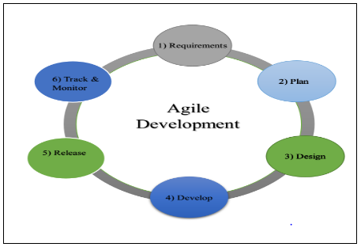

Figure 1. Agile Development Cycle

* Requirements- In this phase, system’s requirements is being gathered. This is meetings takes place in order to determine all the requirements like; Who are the future users of this system? How will they use the system? Is the system easy for them to use? What data should be input into and output by the system?
* Plan- The first step to do. This is where you think about your system’s functionality, the use and importance of it. Including your design, method, and over all coverage of the system.
* Design- This is where the system design is being prepared from the requirements specifications which we are gathered in the first phase. System Design helps in specifying hardware and system requirements.
* Develop- In this phase, is where how you develop your system. Development helps you make the system more productive.
* Release-This is where you allow the system available to release its findings.
* Track & Monitor- After you have plan, design, develop and release, this is where you start to track and monitor as the system’s functionality.

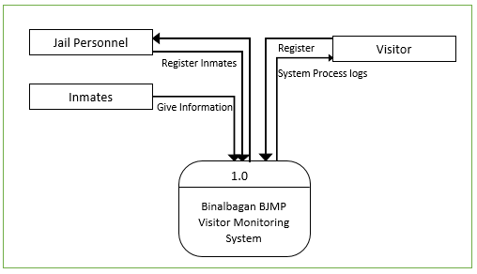**Context Diagram**

Figure 2. Context Diagram of Binalbagan BJMP Visitor Monitoring System

Figure 2 shows the general processes of the developed system. It demonstrates the registration of the inmates’ visitor when they want to enter the jail to visit the inmates.

**Data Flow Diagram**

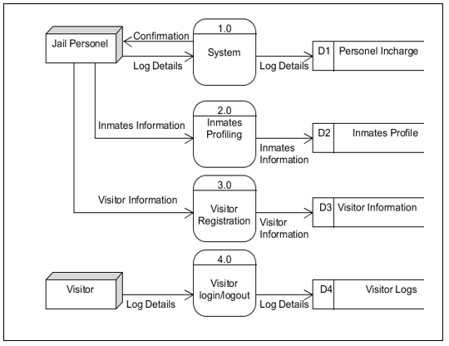

Figure 3. Data Flow Diagram of the Developed System

Figure 3 shows the entire data flows, the processes, input requirements, processed outputs and the storage of developed system.

**Use Case Diagram**

The use case diagram shows the user’s interaction with the system and its relationship between different use case and the user is involved.

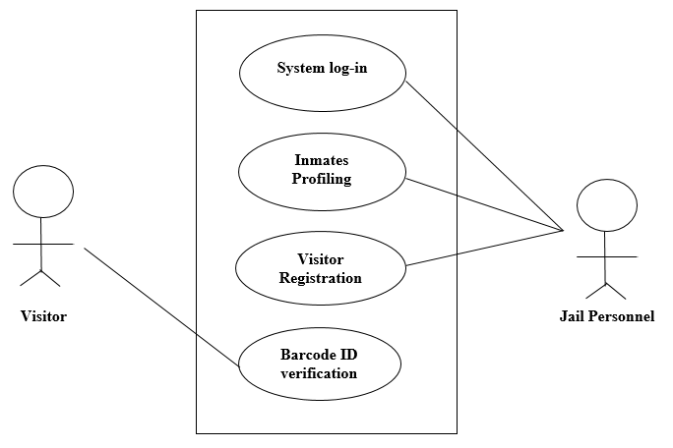

Figure 4. Use Case Diagram of the Proponents Developed System

Figure 4 shows the major task that the actor must be done in order to implement the system. As the figure shows, the Jail Personnel has an account and can access the system and he is the one who is responsible for inmates and visitor registration. The visitor will under registration in their first visit and will undergo verification process every time they visit.

The corresponding use case description for the above actors are:

**Jail** **Personnel**: the one who will be going to use this system in order to monitor the inmates’ visitor registration and log in.

**Visitor**: The visitor will undergo verification process with the use of barcode scanner.

**Use Case Description**

The table below describes the interaction between the user and the system and different use cases that the user is involved. It uses to identify, clarify and organize system requirement. It represents the goal of an interaction between an actor and the system.

Table 2: Inmates Profiling

|  |  |
| --- | --- |
| **Use case name:** | Inmates Profiling |
| **Primary Actor:** | Jail Personnel |
| **Description:** | This use case describes how the registration of inmates work. |
| **Pre-condition:** | The Jail Personnel will log on the system |
| **Post-condition:** | The inmates was successfully registered and all information will be save in the database of the system. |
| **Alternative Flows:** | None |
| **Normal Flow:** | 1. The Jail Personnel will get information from the inmates.  2. The Jail Personnel will encode information of inmates in the system.  3. The system will capture the image on inmates and will be save in the database of the system.  3. The System will save all information encoded by the Jail Personnel. |

Table 3: Visitor Registration

|  |  |
| --- | --- |
| **Use case name:** | Visitor Registration |
| **Primary Actor:** | Visitor |
| **Description:** | This use case describes how the registration of inmates work. |
| **Pre-condition:** | The visitor should undergo registration in the system. |
| **Post-condition:** | The visitor will be having a registered ID. |
| **Alternative Flows:** | None |
| **Normal Flow:** | 1. The visitor should give the information needed.  2. The visitor will be having a registered ID. |

Table 4: Barcode ID verification

|  |  |
| --- | --- |
| **Use case name:** | Visitor log |
| **Primary Actor:** | Visitor |
| **Description:** | This use case describes the visitor verification process. |
| **Pre-condition:** | The visitor will bring ID card. |
| **Post-condition:** | The visitor can access the jail. |
| **Alternative Flows:** | None |
| **Normal Flow:** | 1. The visitor should bring the registered ID  2. The ID will be scan by barcode scanner.  3. The visitor log will be save in the database of the system. |

**Activity Diagram**

The activity diagram shows the flow of inmates and visitor registration and their logs.

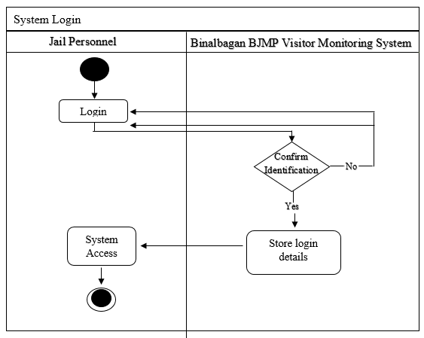

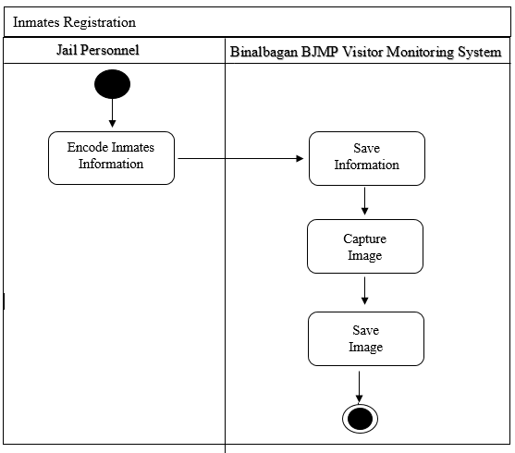

Figure 5. Inmates Registration Activity Diagram of the Developed System

Figure 5 shows the steps of how inmates is being register in the system, the Jail Personnel is responsible of the data entry. It include the process of adding and updating inmates information.

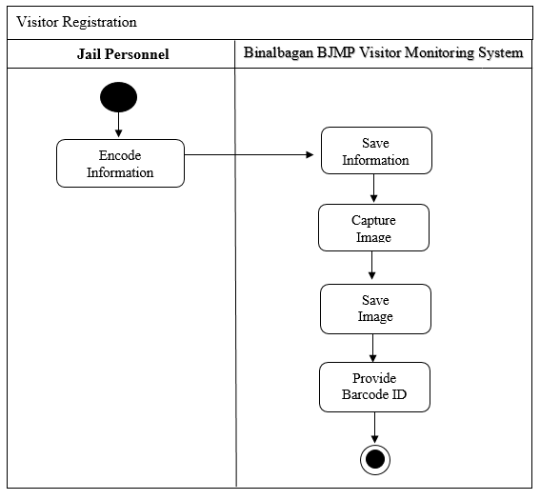

Figure 6. Visitor Registration Activity Diagram of the Developed System

Figure 6 shows the steps of Visitor Registration in their first visit. Jail Personnel will encode visitor information and after registration the visitor will be having a registered ID that will be scanned by a barcode scanner every time they visit the jail.

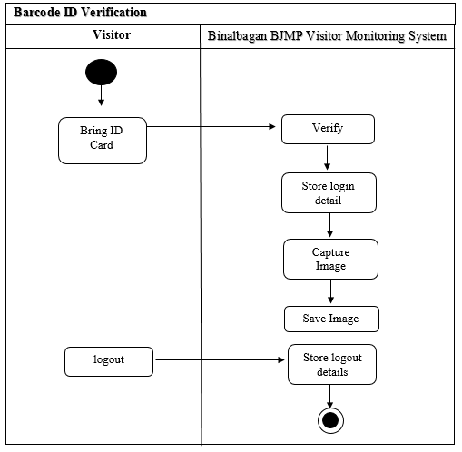

Figure 7. Visitor Log Activity Diagram of the Developed System

Figure 7 shows the steps of repeat visit verification using barcode scanner. The visitor will bring ID card and will be verified by the system and automatically store the log details in the database of the system.

**Decomposition Chart**

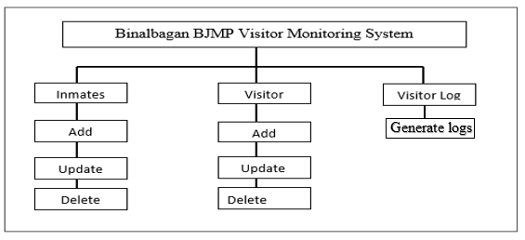 Decomposition Chart shows the break down process and its sub-processes of the whole system.

Figure 8. Decomposition Chart of Binalbagan BJMP Visitor Monitoring System

Figure 8 shows the breakdown and its sub-processes of the developed system. Every process is being labelled and mark to equate the functionality of the whole system.

**Conceptual Framework**

The Operational framework provides the processes and interaction of the user to the system. The diagram shows how data is being process.

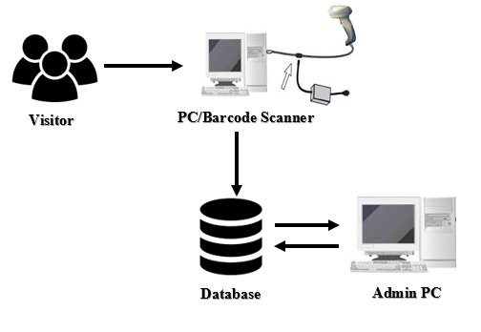

Figure 10. Operation Framework

Figure 10 shows the process of how the data is being process and stored. It include the visitor undergo verification using barcode scanner and directly save to the database of the system.

**System Testing and Implementation**

In order to determine whether the system works accurately and reliably, the proponent test the system to secure that the hardware and software works properly and to prove that the system is accurate in monitoring visitor login and logout.

**Features of proposed project**

The Binalbagan BJMP Visitor Monitoring System have some features to determine visitor logs and recording of inmates information.

* The system provides data storage for inmate’s information.
* The Jail personnel can view personal information and their cases.
* Provides Barcode ID to the visitor
* The system can provide report of inmate’s information.
* The system can provide report of visitor logs.
* The system has an automatic verification of visitor with the use of barcode scanner.

**Recommended Hardware Specification (Server, Workstation)**

For Binalbagan Jail Monitoring System is develop to perform in an appropriate and reliable function.

* Mouse and Keyboard
* Monitor
* CPU(Central Processing Unit)
* Ram
* Barcode Scanner
* Camera

**Recommended Software Specification (Server/Workstation)**

* MyQL, Apache
* HeideSql (for database)
* Netbeans 8.1(ZSDK)
* Windows (OS)

**Data Dictionary**

The tables below show the list of all tables and the data stored in the database on the Binalbagan BJMP Visitor Management System. It provides the attributes, data types and also the description for each fieldnames to recognize the data being stored in the database.

Table 5: Data Dictionary

|  |  |  |  |
| --- | --- | --- | --- |
| Field Name | Description | Type | Length |
| InmatesID | Inmates ID | INT | 5 |
| Prisoner | If Prisoner | VARCHAR | 50 |
| Detainee | If Detainee | VARCHAR | 50 |
| Name | Inmates Name | VARCHAR | 50 |
| Age | Age | INT | 50 |
| Sex | Sex | VARCHAR | 50 |
| Alias | Alias | VARCHAR | 50 |
| Bday | Birthday | VARCHAR | 50 |
| Bplace | Birth Place | VARCHAR | 50 |
| Address | Address | VARCHAR | 50 |
| Status | Status | VARCHAR | 50 |
| Religion | Religion | VARCHAR | 50 |
| EducAttain | Education Attainment | VARCHAR | 50 |
| Height | Height | VARCHAR | 50 |
| Weight | Weight | VARCHAR | 50 |
| build | Build | VARCHAR | 50 |
| eye | Eye | VARCHAR | 50 |
| hair | Hair | VARCHAR | 50 |
| complex | Complexion | VARCHAR | 50 |
| nation | Nationality | VARCHAR | 50 |
| mark | Marks | VARCHAR | 50 |
| FathersName | Fathers Name | VARCHAR | 50 |
| MothersName | Mothers Name | VARCHAR | 50 |
| WifeOrHusband | Wife Or Husband | VARCHAR | 50 |
| Children | Children | VARCHAR | 50 |
| Occupation | Occupation | VARCHAR | 50 |
| notify | Person to notify | VARCHAR | 50 |
| ACRno | ACR no | VARCHAR | 50 |
| CrimeCom | Crime Committed | VARCHAR | 50 |
| DateCom | Date Committed | VARCHAR | 50 |
| CaseNo | Case No | VARCHAR | 50 |
| TrialCrt | Trial Court | VARCHAR | 50 |
| term | Term | VARCHAR | 50 |
| DateSen | Date Sentenced | VARCHAR | 50 |
| Counsel | Counsel | VARCHAR | 50 |
| CAddress | Counsel Address | VARCHAR | 50 |
| PrevRec | Previous Record | VARCHAR | 50 |
| PrevTri | Previous Trial Court | VARCHAR | 50 |
| Sentenced | Sentenced | VARCHAR | 50 |
| DateRel | Date Release | VARCHAR | 50 |
| Image | Image | LONGLOB |  |

Table 6: Visitor

|  |  |  |  |
| --- | --- | --- | --- |
| Field Name | Description | Type | Length |
| VisitorsID | Inmates ID | INT | 5 |
| Name | Visitor Name | VARCHAR | 50 |
| Address | Address | VARCHAR | 50 |
| Sex | Sex | VARCHAR | 50 |
| Who | Inmates to be visited | VARCHAR | 50 |
| relationship | Relationship with inmates | VARCHAR | 50 |
| case | Inmates Case | VARCHAR | 50 |
| image | Visitor Image | LONGLOB |  |

Table 7: Visitor log

|  |  |  |  |
| --- | --- | --- | --- |
| Field Name | Description | Type | Length |
| VisitorsID | Visitor ID | INT | 5 |
| Time in | Time in | DATE/TIME |  |
| Time out | Time out | DATE/TIME |  |

Table 8: Jail Personnel

|  |  |  |  |
| --- | --- | --- | --- |
| Field Name | Description | Type | Length |
| JailPersonnelID | JailPersonnelID | INT | 5 |
| Name | Name | VARCHAR | 50 |

**Entity Relationship Diagram**

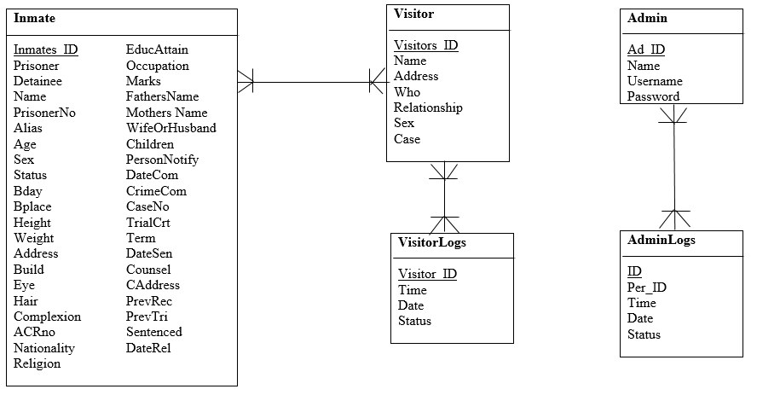

Figure 9. Entity Relationship Diagram of the Proponents Developed System

Figure 9 shows the connections of all tables in the database. Each table requires specific information in order the system works.